*Разработчик*: М.Г. Валиева

*Курс:* Английский язык

*Тема:* Части машины

Прочитайте текст. Внимательно рассмотрите рисунок.

Сделайте подписи к рисунку на английском языке.

MaterialsaCaris Made of

A сar is made of different materials. A windscreen, for example, is made of glass. Headlights are also made of glass. Tyres are made of rubber. They are filled with air.An air in tyres is compressed (to approximately 1,5gm/cm3). A body is made of metal. A metal is painted. A steering wheel is made of plastic. Mirrors are made of plastic and glass. A rear-view mirror is fixed to the roof. A wing mirror is fixed to the door. The car in the figure 1 has two wing mirrors.

An engine is made of different metals. Pistons are made of aluminum and valves are made of steel. Springs are also made of steel.

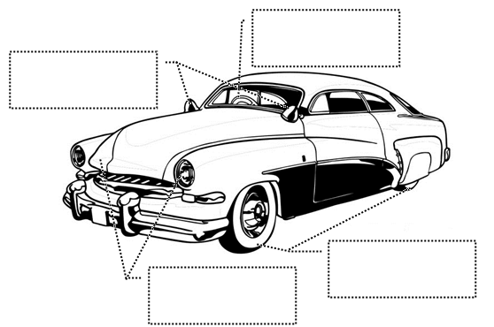

Fig. 1. Materials a Car is Made of

Инструментпроверки

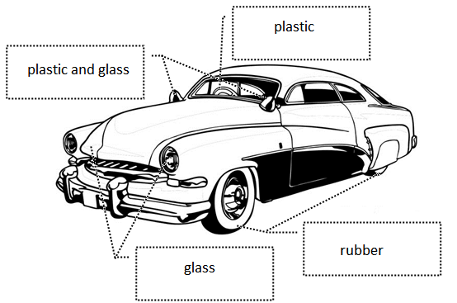

Fig. 1. Materials a Car is Made of

|  |  |
| --- | --- |
| За каждый верно указанный материал | 1 балл |
| ***Максимальный балл*** | ***5 баллов*** |