Задание подготовлено в рамках проекта АНО «Лаборатория модернизации образовательных ресурсов» «Кадровый и учебно-методический ресурс формирования общих компетенций обучающихся по программам СПО», который реализуется с использованием гранта Президента Российской Федерации на развитие гражданского общества, предоставленного Фондом президентских грантов.

Разработчик: Кутрова Елена Александровна, ГБПОУ СО «Самарский торгово-экономический колледж»
Курс: ОГСЭ 04. «Иностранный язык» (43.02.01 Организация обслуживания в общественном питании)
Тема: Алкогольные напитки. Вина

В ресторан, где Вы проходите практику в качестве официанта, приезжают иностранные гости. Вам поручено подавать гостям вино.
Изучите советы по сервировке алкогольных напитков (вин). (Текст 1). Ознакомьтесь с ассортиментом имеющихся в ресторане напитков. (Текст 2). Организуйте полученную информацию так, чтобы Вы могли максимально быстро ответить на вопросы и выполнить пожелания гостей, сверившись со своей «шпаргалкой».
Foreign guests come to the restaurant where you practice as a waiter. You are charged with serving wine to your guests.
Learn tips for serving alcoholic beverages (wines). (Text 1. Basic Wine Service for Dining Room Staff). Check out the range of drinks available at the restaurant. (Text 2. Wine Assortment). Organize the information received so that you can answer questions as quickly as possible and fulfill the wishes of the guests by checking with your "cheat sheet".
Text 1

Basic Wine Service for Dining Room Staff
WHAT IS WINE? “Wine is the alcoholic beverage obtained from the fermentation of the juice of grapes. Wine is broken down into different groups of: Still Wine, Sparkling Wine and Fortified Wine. Each of these different types of wine is served in a different manner.
So, you should follow basic rules how to serve wine to the guest:
1. Serving temperature for the wines is different. For example, aperitif wines are served lightly chilled before the meal. Light red wines are served at room temperature. Serve Sweet dessert wines very cold for a dessert.
2. Rules for pairing food with wine. There are no fixed rules for pairing food with the right wine but there are guidelines by following. Light foods such as fish and white meat with white wine. Heavy foods such as beef and pasta with meat sauce with red wine. Champagne with all foods, including desserts. Remember if guests know what they want, give it to them do not try to change their minds.
3. Prepare to sell wine: review the dinner menu and the wine list for the evening. Review all information wine categories (white, red blush), bin number, name of wine, winemaker, price, age, description (color, smell, taste).
4. Introduce yourself. Tell your guests you are responsible for wine service as well as food service, call attention to the Wine List. Recommend the wine that match with the meal using some words such (light, rich, fruity, crisp, dry, well balanced, full bodied) to describe wines.
5. As far as pouring wines is concerned the order is young before old and dry before sweet. Take care not to shake the bottle, pout wines gently and never fill more than two thirds the glass to enjoy its bouquet.
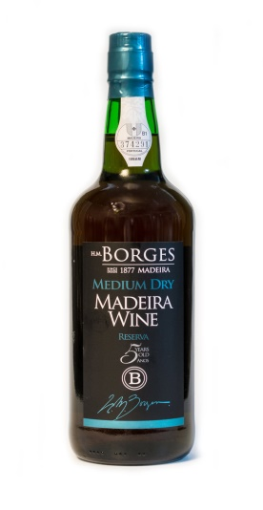 | WINE ASSORTMENT. Technical Datasheet  - Madeira WINE  Type: Medium-Dry  Lot: Tinta negra from different harvest years, aged part in oak casks and part in stainless steel, with an average of 5 years old.  Region: Madeira  Grape variety: Varietal Tinta Negra  Terroir: Volcanic and basaltic soils, with a clayey texture, acids and rich in organic matter. A mild sub-tropical climate, warm summers and temperate winters. Great proximity between vineyards and the sea which gives to the wines a perfect acidity.  Vinfication: Destemmed grapes. Soft fermentation on the skins in controlled temperatures. Fortified by the addition of neutral vinous alcohol at 96% Vol  Aging:Traditional "estufagem" process with temperatures between 35ºC and 45ºC followed by an aging period in oak casks.  Wood: for > 4 years.  Type of wood: French and American oak.  Predicted longevity: Madeira wines, by their characteristics and fortification, are of great longevity.  Analysis: Alcohol content: 18% Vol. Total Acidity: 5,3 gr/l (tartaric acid) Residual sugars: 116,5 pH: 3,54  Tasting Notes: Color: Topaz color with yellowish nuances.  Aroma: Woody aroma, evolved by the aging process, with some spices notes.  Palate: On the palate it is presented as a round wine, notes of seaweed and nuts.  Trade:750ml bottles  6 or 12 bottles per case  Serving Suggestion/Food Pairings:  It should be served at a temperature between 13ºC and 14ºC. It does not need to be decanted.  Great for serving as an aperitif or to accompany some starters.  Storage: Vertically in a room temperature. After opening the wine will keep for several months in good conditions.  Oenologist: Ivo Couto
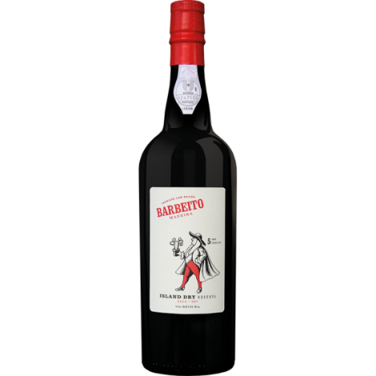 | - BARBEITO MADEIRA  LOT Tinta Negra aged in French oak casks for over 5 years by Canteiro method. For this blend we selected wines from our warehouses with stable temperatures year round that originate a very well balanced wine in sugar and acidity.  TECHNICAL SPECIFICATIONS Alcohol: 19,00% Vol. Baume: 2,7 Total sugar: 83 g/l Volatile Acidity: 0,36 Total Acidity: 5,14 pH: 3,51, Medium Sweet.  SERVING & CELLARAGE This wine was naturally aged in casks and bottled in its purest state. To show it at its best serve between 13ºC/14ºC and should be kept in a cool dry place. This wine was filtered and does not require decanting. It was bottled ready for drinking and will keep well several months after opening.  TASTING NOTES AND HARMONIES Bright gold colour Floral aroma, ripe citrus and orange leaf. Unctuous and well balanced between sweet and acidity, very persistent.  Excellent as digestif, with dried fruits, desserts, smoked ham and cheese.
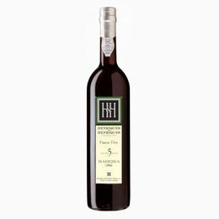 | - MILES MADEIRA WINE  The firm that was eventually to become Miles Madeira was originally known as Rutherford & Grant, established on the Island of Madeira, in 1814. In 1878, James Price, surviving partner of the firm, was no newcomer to the company for, in 1863 when only 12 years old, he had been apprentice to Rutherford & Grant, having acquired sound knowledge and experience of the working of the Madeira Trade. His sons and grandsons followed him in the business, and Miles Madeira became one of the most respected brands of the island’s wine. Today it is synonymous with excellent Madeira wine and has become one of the best known and most respected brands in the world.  GRAPE VARIETY The Tinta Negra varietal originates from Andalucia in the south of Spain and was introduced to the island of Madeira during the 18th Century. Used in large scale after the Phylloxera epidemic in 1872, it is now the most widely planted and most important varietal in Madeira. This red varietal is almost exclusively grown in the “latada” system - trained on a pergola, some 2 metres | 6 feet off the ground in order to maximize aeration below the vines. It is found on the steep slopes on the south of the island in Estreito de Câmara de Lobos (altitudes: 200-600 metres | 656-1968 feet) and on the north, in São Vicente (altitudes: 100-400 metres | 328-1312 feet).  VINIFICATION Miles 5 Year Old. Dry underwent fermentation on the skins with natural yeast at between 16℃ - 18℃ | 60.8℉ – 64.4℉ in temperature controlled stainless steel tanks. After approximately 8 days, fortification with grape spirit takes place, arresting fermentation at the desired degree of sweetness.  MATURATION Miles blended Madeiras are made up of 5 or 6 different lots of wine in order to make up the required average age. The lots of wine making up this blend were aged in the traditional “Canteiro” method at the company’s ageing facility at Mercês, in Funchal, Madeira island. Shortly after fortification, the wine is transferred to old American oak casks and placed in specific rooms that will ultimately determine the end profile of the wine. As the natural heating of the wine plays such an important role throughout the process, every batch of wine needs to be reviewed annually by our winemaker to determine when it will be used as a blend.  SPECIFICATION Alcohol: 19% ABV pH: 3.30 Residual Sugar: 45.0 g/l Total Acidity: 6 g/l tartaric acid  SERVING & CELLARAGE Miles 5 Year Old Dry is fined and does not require decanting. When it comes to enjoying Madeira, we suggest that the dry and medium dry styles be served chilled (12°C). It is excellent as an aperitif but is also exceedingly good with starters, fish dishes and Indian cuisine. It has been bottled when ready for drinking and will keep for several months after opening.  TASTING NOTES Pale topaz colour with golden highlights. Characteristic bouquet of Madeira with notes of dried fruits and citrus flavours. Fresh and persistent finish.
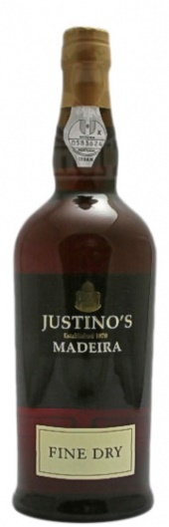 | - JUSTINO’S MADEIRA  WINE STYLE: Reserve | Fine Dry | 5 Years Old. DENOMINATION: DOP Madeira (Denominação de Origem Protegida).  GEOGRAPHICAL LOCATION: Madeira Island (Portugal). Situated in the Atlantic Ocean, about 900 Km south-west of Lisbon and 600 Km west, from the North African coast.  SOIL TYPE: Several mixtures of soils derived mainly of basalt, trachytes and trachydolerites, tufa, scoria and conglomerates.  CLIMATE: The geographical position and mountains landscape allows a very pleasing climate. Temperatures are about 22ºC in the summer and about 16ºC during the winter. With its mild humidity, the island weather is classified as subtropical with variations in temperature, humidity, and rainfall according to altitude.  PRINCIPAL GRAPE GROWING AREA: Estreito de Câmara de Lobos, Câmara de Lobos, Ponta Delgada and São Vicente.  GRAPE VARIETIES: Mainly Tinta Negra. VINE TRAINING SYSTEM: Latada (traditionally low trellises formed by wire horizontal structures laid over trellis post, usually wood or iron).  HARVEST PERIOD: Starting mid September concluding the 2nd week of October. HARVEST METHOD: Manually in several-weekly selections, according to grape ripeness. VINIFICATION: The grapes are totally destemmed, crushed and pressed. The must obtained was then allowed to ferment at controlled temperature in stainless steel tanks. Fermentation is stopped after 8 or 10 days by addition of neutral grape spirit 96º in order to maintain the desired sweetness degree. Vinification is made in strict accordance with traditional methods. AGEING/MATURATION: Blend of wines submitted to a unique heating process known as Estufagem (45-50ºC during 3 months). After estufagem the wine was aged for at least 5 Years in old oak casks until its bottling.  BOTTLING DATE: At the moment of being shipped to the market.  SENSORY CHARACTERISTICS / TASTING NOTES: Appearance: Golden and attractive colour. Nose | Taste: Elegant and complex nutty aromas. Appealing flavours of dried citrus fruits followed by a tangy acidity and a walnut note on the finish. TECHNICAL WINE ANALYSIS: Alcohol: 19% vol. Total Acidity: 7.29 g/l (as tartaric acid). Total Sugar: 54 g/l RECOMMENDED SERVING TEMPERATURE: 9-11ºC.  SERVING SUGGESTION/FOOD PAIRINGS: Requires no decanting. Soft, delicate and elegant fruit qualities of this medium dry Madeira make it suitable for serving as an aperitif, with olives, canapés, roasted almonds and smoked salmon. STORAGE: The bottle should be kept in vertical position, away from the light, and in an atmosphere of moderate and unchanging temperature.  AGE ABILITY (SERVE UNTIL): Undetermined. After bottled opening the wine will keep for several months in good conditions.  WINEMAKER: Dina Luís / Juan Teixeira
Использованный источник:
http://iba-world.com/wp-content/uploads/2018/09/Product-List-2018-1.compressed.pdf?x44213

Инструмент проверки

Предложена сравнительная таблица для 4 сортов вин | 1 балл
Не предложена таблица | проверка прекращена
Предусмотрены строки для перечисления характеристик вин, влияющих на особенности их сервировки (когда, как (температура) и с какой едой подавать)* | 1 балл за каждую строку. Максимально 3 балла
Не предусмотрены | проверка прекращена
Предусмотрена строка для фиксации типа вина | 1 балл
Предусмотрена строка для фиксации возраста вина | 1 балл
Максимально | 6 баллов
Максимальный балл | 24 балла
* Последовательность любая

Пример ответа:

Name of wine | Madeira  Wine | Barbeito  Madeira | Miles  Madeira Wine | Justino’s  Madeira
When to serve | As an aperitif | As digestif | As an aperitif | As an aperitif,
Serving temperature | between 13ºC - 14ºC | between 13ºC - 14ºC | 12°C (served chilled) | 9-11°C
Food Pairings | Starters | Dried fruits, desserts, smoked ham and cheese | Starters, fish dishes and Indian cuisine | Olives, canapés, roasted almonds and smoked salmon
Type of wine | Medium-Dry | Medium Sweet | Dry | Medium Dry
Age | 5 years | (over) 5 years | 5 years | 5 years

